New Patient Medical Questionnaire And Authorization
All questions contained in this questionnaire are strictly confidential and will become part of your medical record.
Date: _________ Patient Full Name: ____________________________ Date of Birth: __________
How did you hear about us? ___________________________________ SS#:__________________
Please list your physical address & P.O. Box: ___________________________________________
Please list 2 contact phone numbers: __________________________/______________________
Can we communicate with you via: Voicemail- YES NO Email- YES NO
Physical Activity? Vigorous Moderate Sedentary
Race: African American/ Black Caucasian/ White Hispanic/ Latino Other __________
Ethnicity: Hispanic or Latino Non-Hispanic or Latino Other ________________
Relationship: Single Married Divorced Separated Widowed
Education: High School Diploma Some College Associate Degree Bachelor’s Degree Master’s Degree GED- Last grade attended _________

Employment: Are you currently employed? Yes No If not why? ________________

Occupation __________________ If you are disabled and/or retired, list your prior occupation.
Have you ever been treated by another pain management clinic/provider?
YES NO If so, who & when? ____________________________________________________

Prescription Drug Abuse: Have you ever abused prescription medications, such as amphetamines, benzodiazepines, barbiturates, codeine, Demerol, or Morphine? Yes No
Are you currently in or have you ever attended a substance abuse program? Yes No

Alcohol Use: Check one- Daily Weekly Monthly Socially Very infrequently

I Do Not drink Have you ever abused Alcohol? Yes No

Tobacco Use: Chew/Dip Cigarettes None

How much? _______________ How often? ______________ How many years? ____________

Illegal Drug Use: Do you use or have you ever used any of the following illegal drugs?

Drug | Currently Using | Drug | Currently Using
Marijuana | YES NO | LSD | YES NO
Heroin | YES NO | PCP | YES NO
Cocaine | YES NO | Ecstasy | YES NO
Inhalants | YES NO | Methamphetamines | YES NO
Crack | YES NO | Crank | YES NO

Medications- Please list all of the prescriptions, herbal supplements and vitamins that you are presently taking:
Medication Name | Dosage | How many times do you take this daily? | When did you take your last dose?

Medications Allergies- Please list ALL medication names and reaction that occurred:
__________________________ ____________________________ __________________________
__________________________ ____________________________ __________________________
Height: ______ft. ______inches Weight: ________#

Medical History- Check the following that apply now or have occurred in the past:
______ High Blood Pressure/ Hypertension ______ Irregular Heart Beat
______ Diabetes ______ Parkinson’s Disease
______ High Cholesterol ______ Arthritis
______ Heart Disease ______ Kidney Disease
______ Liver Disease ______ HIV/AIDS
______ Seizure/Epilepsy ______ Asthma
______ Thyroid Disease ______ COPD
______ Headaches/Migraines ______ Multiple Sclerosis
______ Cancer, what kind? _______________ ______ Alzheimer’s/ Dementia
______ Stroke ______ Degenerative Disc Disease
______ Peptic Ulcer Disease (PUD) ______ GERD
______ Hepatitis C ______ Acid Reflux
______ Anxiety Other: __________________________________
______ Depression

Family History- Please indicate which family member each applies to, use the abbreviations as follows (M-Mother, F-Father, S-Sister, B-Brother, GP-Grandparent)
_________________ High Blood Pressure/ Hypertension _________________ High Cholesterol
_________________ Diabetes _________________ Heart Disease _________________ Heart Disease _________________ Alzheimer’s Dementia
_________________ Seizure/Epilepsy _________________ Multiple Sclerosis
_________________ Headaches/Migraines _________________ Parkinson’s Disease
_________________ Cancer (List Type) _________________ Muscular Dystrophy
_________________ Stroke _________________ Muscular Dystrophy

Surgical History- Please list all of your past surgeries and the approximate date/year:
SURGERY NAME/DESCRIPTION | DATE/YEAR
How many children have you given birth to? _____________

Prior Treatment: Please fill in the blanks ONLY for the treatments you have had performed for this pain problem. If a treatment performed is not listed, please add it:
Treatment | What Doctor Performed this? | Date/Year Performed | Outcome (check one)  Improved Not Improved
Nerve Block
Epidural Steroid Injection
TENS Unit
Physical Therapy
Traction
Acupuncture
Chiropractic Care
Psychiatrist/Psychologist
Hypnosis/Biofeedback
Alternative Treatments

- Appointment Policy: I understand that no showing for more than TWO scheduled appointments or procedures is grounds for patient discharge. Office visit cancellations must be made with at least a 24-hour notice and procedure cancellations must be made with at least a 72-hour notice. If this policy is not followed, I may be subject to a $25 fee per office visit & $100 fee per procedure. NSF check fee- $25.
- When leaving voicemails, I understand that it may take 24 business hours for the office to respond with an appropriate answer from my provider. Leaving multiple voicemails about the same concern is not necessary and will only delay my response time.
- I acknowledge that I have received a copy of the Notice of Privacy Practices for Cypress Pointe Pain Management. CPPM reserves the right to modify the privacy practices outlined in the notice.
- I consent to receive calls/text from CPPM for my protected health care and other services at the phone numbers I have listed, including my wireless phone number. I understand that I may be charged for such calls by my wireless carrier and that such calls may be generated by an automated dialing system.
- I have read and understand my rights and responsibilities as a patient.
- I understand that I have the right to choose a personal representative.

Release of Information:
CPPM will not be held liable for releasing protected health information to the listed persons, in the event that I fail to report any changes to the above list. Persons whom I give permission to disclose any medical or billing information regarding my care (spouse, family, friends, etc.):
Full Name of Person _______________________________________Relationship_______________
Full Name of Person _______________________________________Relationship_______________
Full Name of Person _______________________________________Relationship_______________

I, the undersigned, authorize the physicians of CPPM to disclose any or all of the information in my medical records to any person, other healthcare provider, pharmacy, reimbursing agency, law enforcement, or other state/federal corporation or agency which is or may be liable for all or part of CPPM’s charge or who may be responsible for determining necessity of health maintenance. I understand that my records may contain diagnosis, toxicology screening results, prescription information, or my history of communicable disease. I understand that it is my sole responsibility as a patient of CPPM to report any changes to this authorization in writing, and it shall remain in effect until revoked by me. A photocopy of this authorization is considered as valid as the original. I understand that I am responsible for any unpaid charges, regardless of insurance coverage, as well as any additional expenses incurred in the collection of this account. I hereby understand and agree with the terms of this agreement, and I was given the opportunity to ask any pertinent questions. I give my consent for evaluation & treatment at CPPM.
Patient/Representative Signature: ____________________________ Date: _____________
*If the patient is physically or legally unable to sign and a guardian signed in place of the patient, please list:
Representative Full Name: __________________________ Relationship to Patient: _______________
Witness Signature: ___________________________________

PAIN DRAWING:
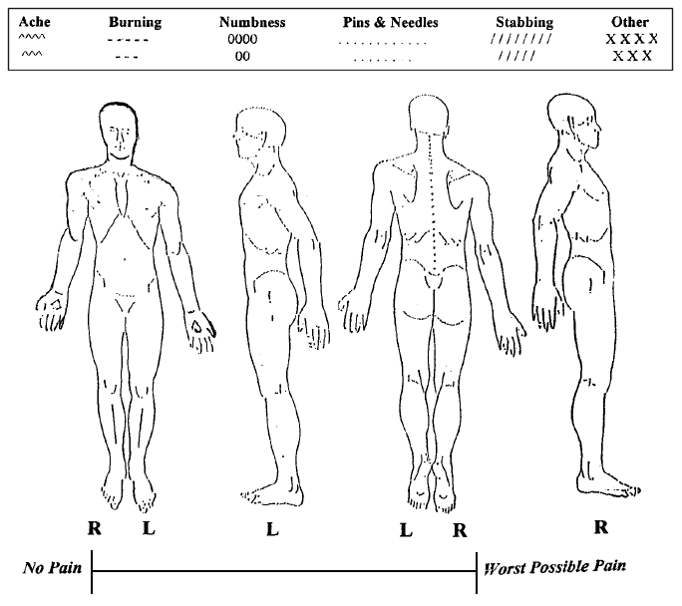

Patient Full Name (PRINT):______________________________ Date of Birth:_______________
Pain Management Treatment Agreement

The goal of this agreement is to establish and maintain a safe and controlled treatment plan. We strive to make your life as pain-free as possible, so you can return to the activities you enjoy.

Benefits:
- We provide diagnostic and therapeutic services for pain.
- We apply the latest advances in medicine to relieve pain.
- We strive to improve function and increase quality of life.
- We organize multidisciplinary approaches to manage other issues accompanying pain, if indicated.
- We provide education on the disease of pain, while providing cost-effective care.
Potential Side Effects of Opioid/Narcotic Medications:
- While all medications have possible side effects, opioid medications are potentially more dangerous with respect to side effects and/or risks. To ensure safe usage and pain control, proper monitoring through drug testing is required. The following stipulations are mandatory for all patients to receive opioid pain management treatment from CPPM.
- Potential side effects of opioid/narcotic medications include: Addiction; Appetite decrease or loss; Balance and/or coordination disruption; Confusion and/or difficulty thinking, concentrating, and focusing clearly; Constipation; Increased drowsiness/sleepiness; Respiratory depression (slowed breathing); Psychological dependence; Tolerance (needing increased amounts of medication over time).
PATIENTS RECEIVING OPIOID (NARCOTIC) TREATMENT MUST AGREE TO ALL OF THE FOLLOWING STATEMENTS.

Office Policies:
- I will keep and arrive in a timely manner for my scheduled appointments. No-showing for more than two scheduled appointments or procedures is grounds for patient discharge. I must provide at least 24-hour notice to cancel an office-visit appointment and at least 72-hour notice to cancel an appointment for a procedure.
- I, and any family members or representatives communicating on my behalf, will be courteous and respectful to all office staff and will not yell, use profanity, or engage in other threatening behavior, whether in person or on the telephone or in other media, when communicating with CPPM staff.
- I understand that when leaving a voicemail, CPPM may require 24 business hours to return my phone call. Leaving multiple voicemails with the same concern is unnecessary.

Medications:
- I am not and will not be involved in any way in the sale, illegal possession, diversion, or transport of prescribed controlled substances.
- I do not have a problem with substance abuse or medication dependence.
- I will not use or abuse addictive or potentially addictive substances, illegal or legal (Cocaine, Alcohol, Narcotics, Marijuana, etc.). Moderate use of nicotine and caffeine are an exception to this restriction.
- I will not use any mood-modifying medication, including tranquilizers and medications for ADHD and the like, from any other prescriber without first discussing this with my CCPM physician, and I will not abuse such medication.
- I will obtain all prescriptions for opioids/Narcotics only from CPPM. I will only take these medications as directed.
- I will not share, give, lose, or allow others to consume my medications. I understand that CPPM does not replace lost or stolen medications.
- I understand that the physicians at CPPM do not write prescriptions for Soma, Xanax, Valium, or Ativan.
- I understand that stopping controlled substances suddenly may result in withdrawal symptoms that can lead to possible heart attack and seizures.
- I understand that my medication treatment may be discontinued if my CPPM physician feels that opioids are ineffective in relieving my pain or improving my functionality.
- Pharmacy: ______________________ I agree to use only one pharmacy to obtain opioid medications. I will notify CPPM immediately if I or my representatives use another pharmacy for any reason.
- I understand that I am required to follow Federal and State guidelines for medication disposal. I will consult with CPPM before disposing of any unused medications. CPPM will instruct me how to properly dispose of these unused medications. Medication changes will not be made unless I comply with this policy.
- I will be subject to random pill counts and random drugs screens and must arrive at the clinic within 24 hours of a request by CPPM for a pill count or drug test.

Additional Treatment:
- I will actively participate in other, additional pain therapies as recommended by my CPPM physician. I understand that treatment can include physical therapy, minimally invasive procedures, psychological services, and may or may not include prescription strength medication.
- I will participate in a chemical dependency program if my CPPM physician identifies a problem.
- I accept responsibility to gradually increase my daily activities as recommended by my physician.
- I understand that CPPM utilizes Mid-Level providers for follow up office visits.

Other Medical Conditions and Other Providers:
- I will immediately notify my CPPM physician if I am or plan to become pregnant.
- I will not obtain or seek controlled substances from any other physicians, including dentists or emergency room physicians. If I receive medical treatment for pain for any reason, I will notify my CPPM physician immediately.
- I will not seek emergency treatment for the pain condition my CPPM physician is treating.
- I will notify any/all of my other providers of my opioid treatment by my CPPM provider. I will not accept any pain medication from any other provider.

Patient Responsibility:
- I assume responsibility in making any important decisions, legal or otherwise, while taking controlled substances, as controlled substances can decrease mental function.
- I assume responsibility for operating any type of automobile, vehicle, machinery, or any potentially hazardous task while taking controlled substances that are prescribed by my physician.

Prescription Refill Policy:
- I understand that opioid prescriptions are not refilled without an office visit. Prescriptions for opioid refills are available only through a scheduled visit during regular office hours.
- I take responsibility to plan ahead, arrive for office visits as scheduled, take my medications as prescribed, and to know when my refills are due to prevent running out of medication prior to my next scheduled appointment.
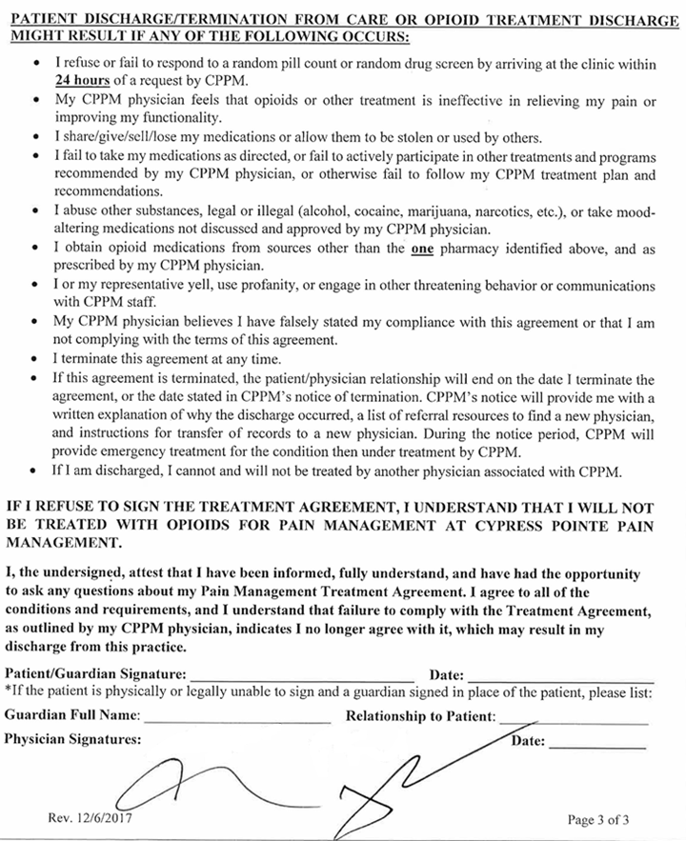
Mailing Address: 76 Starbrush Circle
Covington, LA 70443
Phone: (985) 892-8934
Fax: (985) 892-8937 - Covington
Fax #2: (985) 345-3379 - Hammond
www.cppain.com

AUTHORIZATION FOR THE RELEASE OF PROTECTED HEALTH INFORMATION
Patient Full Name: _________________________ Date of Birth: ____________ Phone#: _______________
Authority to Release Protected Health Information
I hereby authorize ________________________, to release the information indicated below to:
(Doctor or Mid-Level Name)
Physician Office/Requesting Facility: _________________________ Provider: ___________________
Address: ___________________________________________________________________________
Phone #: _________________________ Fax #: ___________________________
Covering the Periods of Health Care
I authorize the release of the health records indicated below that cover the period of health care from (date) ______________________________ to (date) ______________________________.

Type of Information to be Released
My complete health record, OR
Only the following information:

Diagnosis & treatment codes | Discharge summary | History & physical exam
Consultation reports | Progress Notes | MRI reports
X-ray reports | CT reports
Other, specify: _________________________________________________________

I understand that my health record may include information about mental health diagnosis or treatment; alcohol, drug, and/or controlled substance abuse, diagnosis, or treatment; or HIV/AIDS diagnosis or treatment. Only initial one on each line below:

I do _____ /do not ____ authorize the release of information pertaining to mental health.
I do _____ /do not ____ authorize the release of information pertaining to alcohol or drug abuse.
I do _____ /do not ____ authorize the release of information pertaining to HIV/AIDS.
Purpose of the Requested Disclosure
I am authorizing the release of my Protected Health Information for the following purposes:
Medical Care Insurance At the request of patient
Other (specify)______________________________________________________
Time Period for this Authorization
This Authorization will expire on the following date, event or condition ____________________________, or within one (1) year of the below date of this Authorization, whichever occurs first.
Revocation of This Authorization
I understand that I have the right to revoke this Authorization at any time to prohibit future release of my information. To revoke this Authorization, I must send written notice to Cypress Pointe Pain Management, to the attention of the office manager, at the address indicated above. I understand that my revocation of this Authorization applies to future disclosures only and will not have any effect on any disclosures of Protected Health Information made before receiving the revocation.
Redisclosure
I understand that my Protected Health Information disclosed pursuant to this Authorization may be redisclosed by the recipient identified above, and may no longer be protected from disclosure to others by federal or state law.
Waiver
I hereby expressly waive any claim of privilege or privacy with respect to the released information. I release and forever discharge Cypress Pointe Pain Management and its agents, servants, or employees from all liability or claims, of any kind or character, in any way arising out of the disclosure of the requested information, including disclosures made in good faith.
Voluntary
I understand that signing this authorization is voluntary. My treatment, payment, enrollment in a health plan, or eligibility for benefits will not be conditioned upon my authorization of this disclosure.
Signature of Patient/Patient’s Representative: Date:
_________________________________________ _____________________________
Print Name of Patient’s Representative: Relationship to Patient:
_________________________________________ ______________________________

